**DAILY ONLINE ACTIVITIES SUMMARY**

|  |  |  |  |  |  |  |  |  |
| --- | --- | --- | --- | --- | --- | --- | --- | --- |
| **Date:** | **17/06/2020** | | | | | **Name:** | **Spoorthy Balaji** | |
| **Sem & Sec** | **6th & B** | | | | | **USN:** | **4al17cs098** | |
| **Online Test Summary** | | | | | | | | |
| **Subject** | | **Programming in C** | | | | | | |
| **Max. Marks** | | **15** | | **Score** | | | **12** | |
| **Certification Course Summary** | | | | | | | | |
| **Course** | Programming in C  Applications of python in DA and ML | | | | | | | |
| **Certificate Provider** | | | **Vivek Sharma**  **Dr. Mohideen**  **Badusha** | | **Duration** | | | **4hours** |
| **Coding Challenges** | | | | | | | | |
| **Problem Statement:** 3 Programs | | | | | | | | |
| **Status: Solved** | | | | | | | | |
| **Uploaded the report in Github** | | | | | **yes** | | | |
| **If yes Repository name** | | | | | **Online Coding Repository**  <https://github.com/spoorthybalaji/Daily_Status>  **Workshop on Application of python**  <https://github.com/spoorthybalaji/Online-Workshop-on-Applications-of-Python-programming-in-DA-and-ML> | | | |
| **Uploaded the report in slack** | | | | | **yes** | | | |

Programming in C Quiz

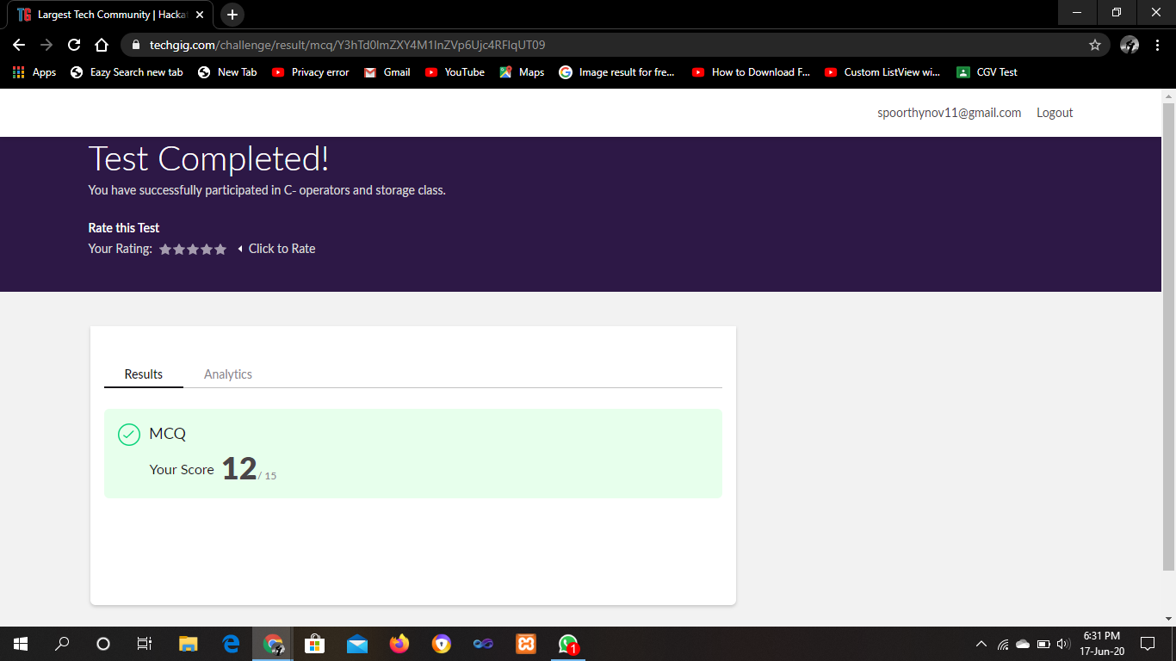

**SNAPSHOTS**

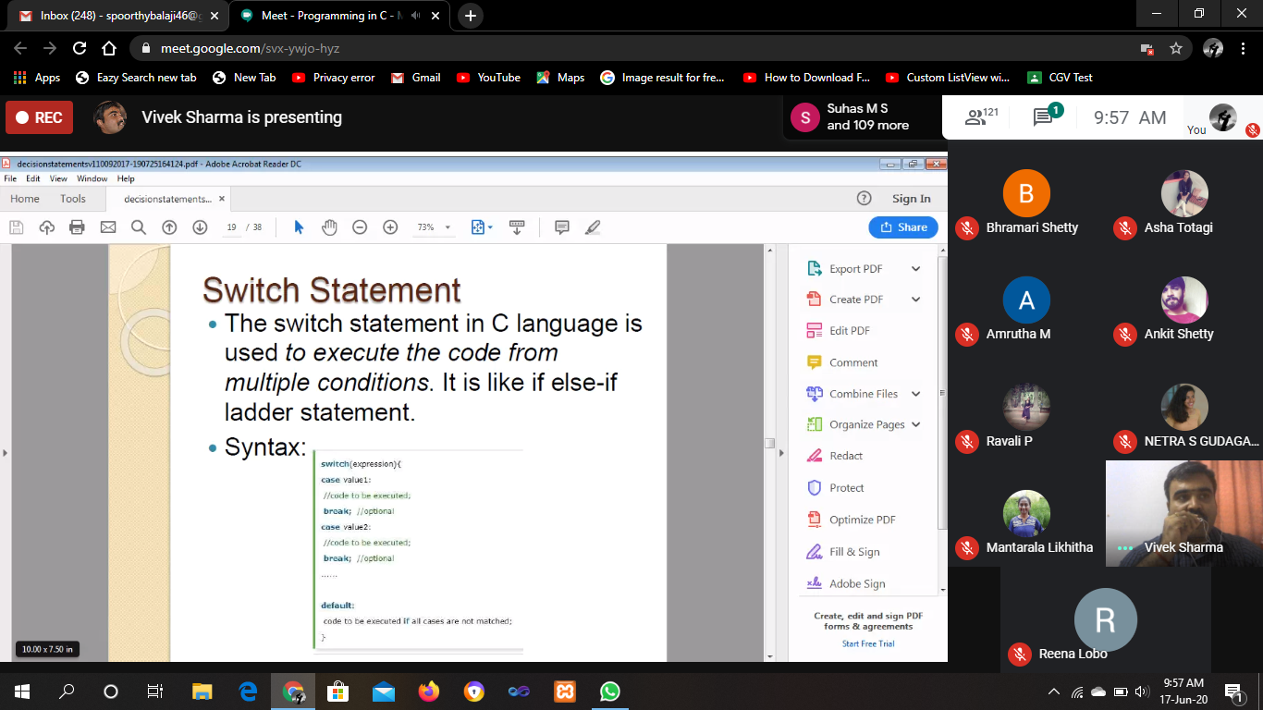



ONLINE CODING

**1.  Python Program to Take in Two Strings and Display the Larger String without Using Built-in Functions**

string1=input("Enter first string:")

string2=input("Enter second string:")

count1=0

count2=0

for i in string1:

count1=count1+1

for j in string2:

count2=count2+1

if(count1<count2):

print("Larger string is:")

print(string2)

elif(count1==count2):

print("Both strings are equal.")

else:

print("Larger string is:")

print(string1)

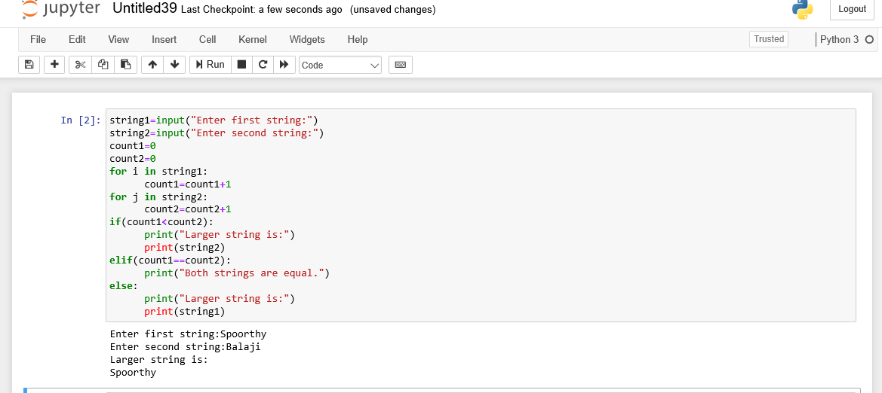

**2. Write a Java program to find the row, column position of a specified number (row, column position) in a given 2-dimensional array**

importjava.util.*;

publicclassabc

{

publicstaticvoidmain(String[]args){

intnums[][]={{12,20,30,40}, {15,25,35,45}, {24,29,39,51}, {35,30,39,50}, {50,60,75,72}};

int rows =5;

intsearch_element=39;

intans[]=Saddleback(nums, rows -1,0,search_element);

System.out.println("Position of "+search_element+" in the matrix is ("+ans[0]+","+ans[1]+")");

}

privatestaticint[]Saddleback(intnums[][],int row,int col,intsearch_element)

{

intelement_pos[]={-1,-1};

if(row <0|| col >=nums[row].length){

returnelement_pos;

}

if(nums[row][col]==search_element){

element_pos[0]= row;

element_pos[1]= col;

returnelement_pos;

}

elseif(nums[row][col]>search_element){

returnSaddleback(nums, row -1, col,search_element);

}

returnSaddleback(nums, row, col +1,search_element);

}

}

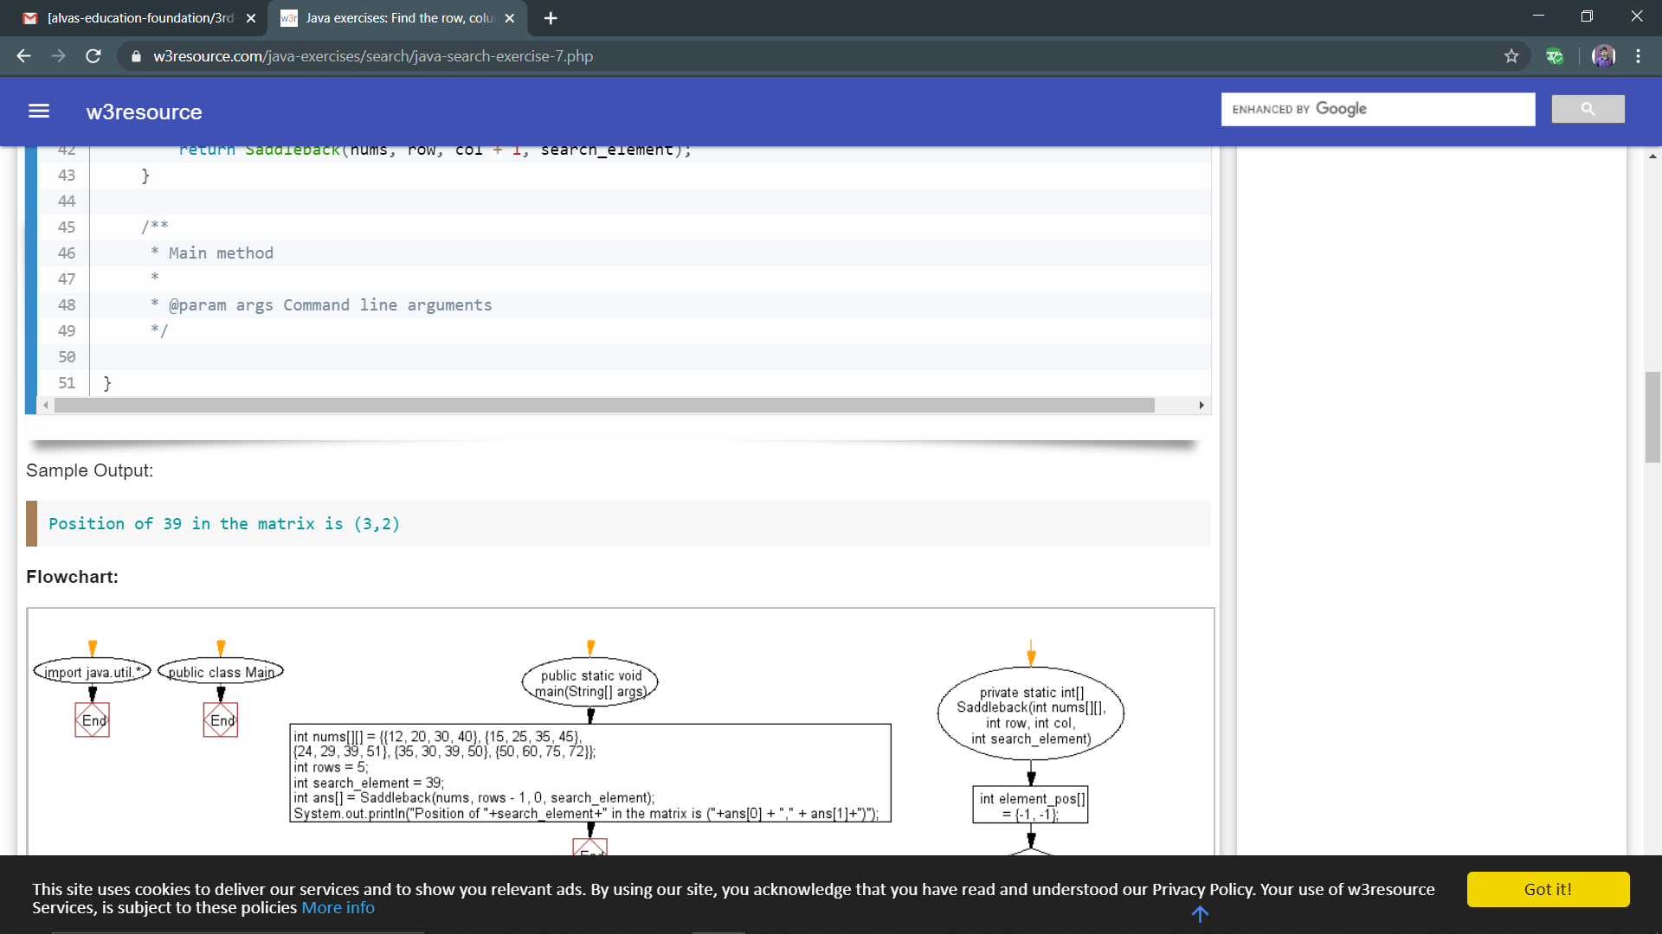

**3. Find the smallest positive integer value that cannot be represented as sum of any subset of a given array sorted in ascending order.**

#include <stdio.h>

int findSmallest(int arr[], int n)

{

int res = 1;

for (int i = 0; i < n && arr[i] <= res; i++)

res = res + arr[i];

return res;

}

int main()

{

int arr1[] = {1, 3, 4, 5};

int n1 = sizeof(arr1)/sizeof(arr1[0]);

printf("output1: %d\n", findSmallest(arr1, n1));

int arr2[] = {1, 2, 6, 10, 11, 15};

int n2 = sizeof(arr2)/sizeof(arr2[0]);

printf("output2: %d\n", findSmallest(arr2, n1));

int arr3[] = {1, 1, 1, 1};

int n3 = sizeof(arr3)/sizeof(arr3[0]);

printf("output3: %d\n", findSmallest(arr3, n1));

int arr4[] = {1, 1, 3, 4};

int n4 = sizeof(arr4)/sizeof(arr4[0]);

printf("output4: %d\n", findSmallest(arr4, n1));

return 0;

}

